SINGAPORE POLYTECHNIC
SCHOOL OF COMPUTING

COMMON INFOCOMM TECHNOLOGY PROGRAMME (Year One) DIPLOMA IN APPLIED AI AND ANALYTICS (Year One) DIPLOMA IN CYBERSECURITY AND DIGITAL FORENSICS (Year One)
DIPLOMA IN INFORMATION TECHNOLOGY (Year One)

ST0501 Front-End Web Development AY2526S1
CA1 Website Requirements Template

- Home Page

  - Ideation (You can list down a few ideas below)
- There will be an array of cards in the carousel in main page.
- I will add the names of the clients, their positions, their feedbacks and for their profile photos, I will use free images from freepik.com
- The carousel will slide the cards every 3 seconds. But, when the cursor is hovered above it, it will pause the sliding so that the user can read the reviews.
- At the bottom-right corner of the webpage, the company logo will be fixed.
- Contact Information for Company will be added in Footer.
- The menu will be the hamburger button with interactive offcanvas.
- Motto of Company is “Securing the Future, One Vault at a Time”.

  - Contents (Include contents that you will be using in your home page)
Sarah Thompson, Small Business Owner
CyberVault transformed our cybersecurity with their expert training and phishing protection. Their team’s dedication ensured our data stayed secure, giving us peace of mind. We highly recommend their tailored solutions.
Mark Reynolds, IT Manager
The CyberVault team’s rapid response to a potential phishing attack saved our company from significant losses. Their proactive monitoring and clear communication made all the difference. We trust them completely with our digital security.
Emily Chen, HR Director
CyberVault’s digital wellness workshops empowered our employees to stay safe online. Their engaging training on recognizing cyber threats was both practical and inspiring. We’ve seen a real improvement in our team’s confidence.
David Patel, Startup Founder
Working with CyberVault has been a game-changer for our startup’s cybersecurity. Their customized protection plan blocked phishing attempts and kept our sensitive data secure. Their commitment to our success is unmatched.
Lisa Nguyen, Retail Manager
CyberVault’s clear guidance on digital wellness helped our team balance productivity and security. Their anti-phishing measures protected our customer data, preserving our reputation. We’re grateful for their reliable support.
James Lee, Financial Consultant
The expertise of CyberVault’s Cyber Defenders gave us robust protection against cyber threats. Their tailored solutions and 24/7 monitoring ensured our client information remained safe. They’re a trusted partner in our business.
Rachel Kim, Non-Profit Director
CyberVault’s training turned our staff into confident cyber defenders. Their focus on both security and digital well-being was exactly what we needed. We couldn’t be happier with their service.
Michael Brown, Tech Entrepreneur
CyberVault’s proactive approach stopped a phishing scam before it impacted our operations. Their team’s professionalism and cutting-edge tools make them a leader in cybersecurity. We highly value their partnership.
Anna Rodriguez, Operations Manager
CyberVault delivered exceptional cybersecurity solutions tailored to our needs. Their commitment to transparency and rapid response kept our business secure and our team informed. They truly live up to their Protection Promise.

  - Include a rough sketch of how your home page?
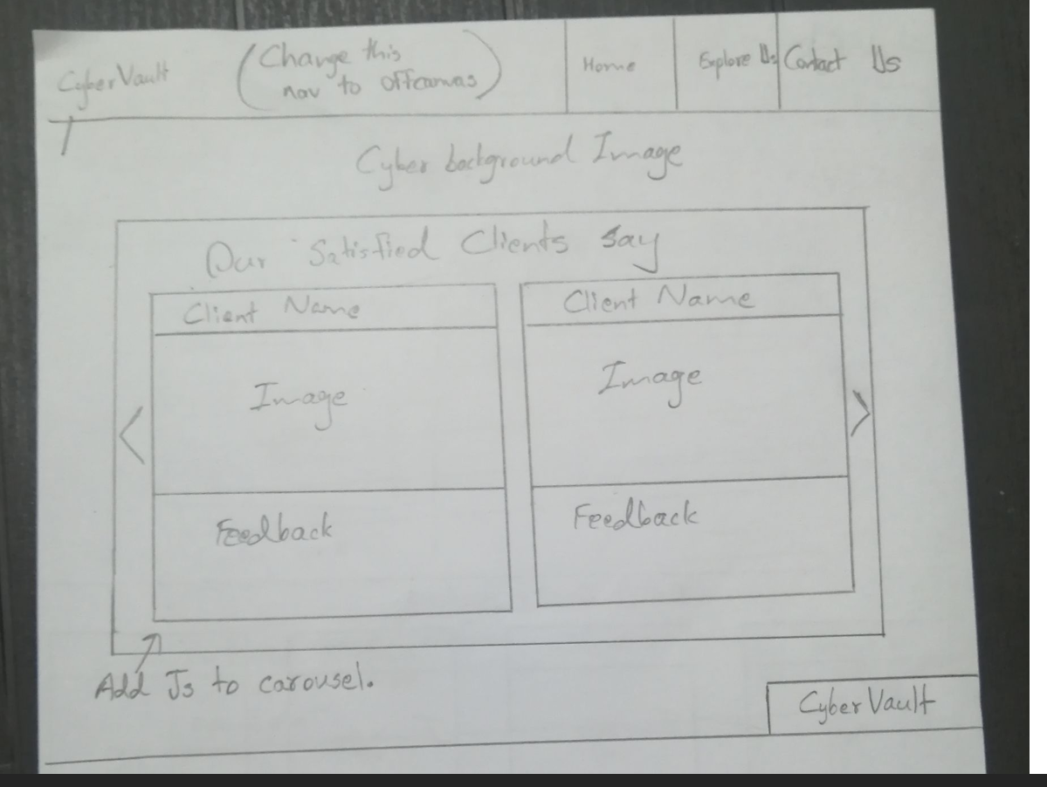
This is the sketch I drew before I started building the pages. Along building the pages, I edited the design appropriately.

- Informational Page

  - Ideation (You can list down a few ideas below)
In “Explore Us” page, there will be three main parts.
- What is phishing? How will we protect you?
- Meet Our Protectors
- Our Protection Promises and
- The footer
Will use free images from freepik.com.
Will use Chatgpt to generate the content for me.

  - Contents (Include contents that you will be using in your home page)

What is Phishing? How will we protect you?
https://youtu.be/Y7zNlEMDmI4?si=b6C3lUqcKDk0iIqn
Phishing is a cyberattack where criminals send fake emails, text messages, or other communications pretending to be from a trusted source to trick people into sharing sensitive information, like passwords or bank details. These attacks can harm businesses by causing data breaches, financial losses, or damage to their reputation when customer or company information is stolen. Employees may unknowingly click malicious links, leading to malware infections that disrupt operations. Phishing can also erode customer trust if their data is compromised. To protect your business, we implement robust email filtering to detect and block phishing attempts. We provide employee training to recognize suspicious messages and maintain strict security protocols. Our proactive monitoring and advanced threat detection ensure your business stays safe from phishing attacks.

Meet Our Protectors
Dr. Elena Martinez
  - Role: Chief Cybersecurity Strategist
  - Bio: Dr. Elena Martinez leads our strategic efforts to protect clients from advanced cyber threats. With over 15 years of experience in cybersecurity, she specializes in threat intelligence and risk assessment, ensuring businesses stay ahead of evolving dangers. She holds a Ph.D. in Computer Science and is a Certified Information Systems Security Professional (CISSP).

James Carter
  - Role: Lead Incident Response Specialist
  - Bio: James Carter is our expert in responding to cyber incidents, minimizing damage, and restoring security. With a background in ethical hacking and a Certified Ethical Hacker (CEH) credential, he identifies vulnerabilities before attackers can exploit them. His quick thinking protects businesses from costly breaches.

Aisha Khan
  - Role: Digital Wellness Consultant
  - Bio: Aisha Khan focuses on helping clients maintain healthy digital habits while staying secure online. With 10 years of experience in cybersecurity training and a certification in Cybersecurity Awareness (CompTIA), she empowers employees to recognize phishing and other threats. Her workshops promote both safety and well-being.

Michael Nguyen
  - Role: Senior Threat Analyst
  - Bio: Michael Nguyen monitors and analyzes emerging cyber threats to keep our clients safe. With expertise in malware analysis and a GIAC Security Essentials (GSEC) certification, he proactively identifies risks and implements cutting-edge defenses. His work ensures businesses operate with confidence.

Our Protection Promise
Uncompromising Security
We are committed to safeguarding your business with cutting-edge cybersecurity solutions. Our advanced email filtering and threat detection systems block phishing attacks, preventing sensitive data breaches. We continuously monitor for emerging threats to ensure your defenses stay robust. Our team uses encryption and secure protocols to protect your digital assets. By staying ahead of cybercriminals, we minimize risks like malware or financial loss. Your security is our top priority, and we never compromise on it. Trust CyberVault to keep your business safe and operational.

Empowering Your Team
We believe an informed team is your strongest defense against cyber threats. Our expert-led training programs teach employees to recognize phishing emails and other scams, reducing human error. We provide engaging workshops on digital wellness to promote healthy tech habits. Our resources empower your staff to use devices securely without compromising productivity. Regular updates ensure your team stays aware of new threats. We tailor training to your business needs, fostering a culture of vigilance. With CyberVault, your employees become active cyber defenders.

Client-Centric Solutions
Our commitment is to deliver solutions that fit your unique business needs. We assess your risks, from phishing vulnerabilities to data exposure, and design customized protection plans. Our proactive monitoring detects threats before they impact your operations. We prioritize clear communication, keeping you informed without technical jargon. Our services, like secure cloud backups and employee training, ensure both security and digital well-being. If a breach occurs, our rapid response team minimizes damage and restores trust. Your success and peace of mind drive everything we do.

Promoting Digital Wellness
We go beyond security to foster a healthy digital environment for your business. Our experts guide you in managing screen time and securing devices to reduce digital stress. We offer tools to balance productivity with well-being, protecting both your data and your team’s mental health. Our anti-phishing measures ensure safe online interactions, building customer confidence. We provide actionable tips to maintain a secure and balanced digital presence. Your business thrives when technology supports both efficiency and wellness. CyberVault is your partner in creating a safer, healthier digital world.

Lasting Trust and Reliability
We build lasting partnerships based on trust and dependable service. Our 24/7 support ensures you’re never alone in facing cyber threats like phishing or malware. We maintain transparency by regularly updating you on your security status. Our certified professionals, backed by credentials like CISSP and CEH, deliver reliable protection. We uphold strict ethical standards to safeguard your reputation and customer trust. Our solutions evolve with your business to provide consistent security. Choose CyberVault for a commitment you can rely on every day.

  - Include a rough sketch of how your home page?
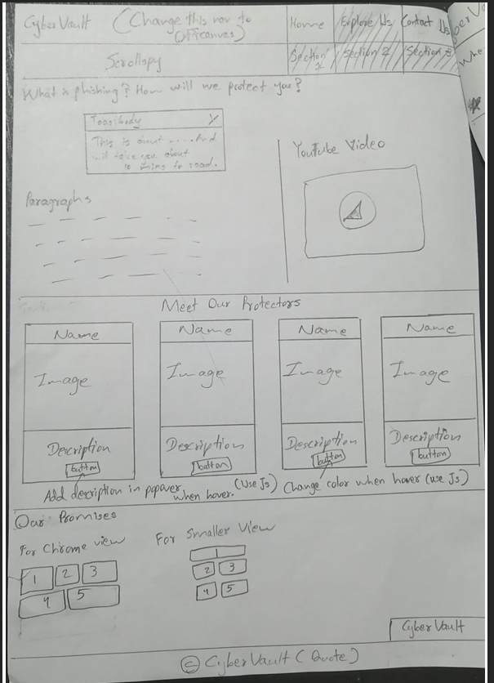

This is the sketch I drew before I started building the pages. Along building the pages, I edited the design appropriately.

- Interactive Form Page

  - Ideation (You can list down a few ideas below)
There will be 7 inputs for the interactive form.
    - Full Name
    - Email Address
    - Phone Number
    - Query Type ( This is Dropdown )
    - Preferred Contact Method ( This is radio button )
    - Briefly Describe Your Concern ( This is textarea ) and
    - Urgency Level ( This is range bar ).

  - Contents (Include contents that you will be using in your home page)
In the Dropdown, the query types will be
- Suspected hack or unauthorized access
- System scan for threats or malware
- Advice on improving cybersecurity
- Website security testing request
- File recovery assistance
- Help with data protection compliance
- Managed security service inquiry
- Cybersecurity training request
- Billing or subscription question and
- Quote or product demo request

In the textarea, the character will be counted as the user type his concern. Up to 500 characters can be typed.

For the range bar, the user can choose the urgency level and will be shown his selection.
After filling all required information, “Query Received” notification will be shown at the top of the page as a modal.
If the user didn’t fill all questions, the form will ask for that information.

  - Include a rough sketch of how your home page?
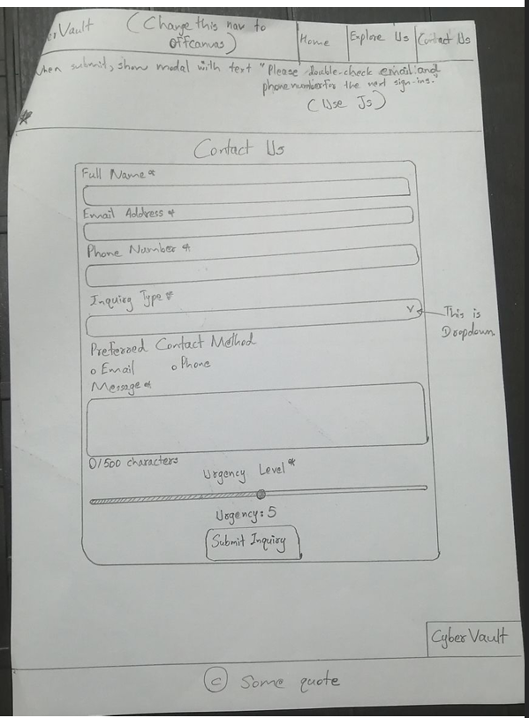

This is the sketch I drew before I started building the pages. Along building the pages, I edited the design appropriately.

I validated all three HTML pages and the CSS page.

